INSTALLATION INSTRUCTIONS FOR FUSION-LOC ACCESSORIES
- Determine the mounting position of your suction cup ensuring that it is not on any grout lines, joints or cracks. Clean the area with methylated spirits or alcohol cleaner and allow to air dry. HANDY HINT: Don’t use household cleaners as they can leave a residue that can interfere with the suction cup.
- Disassemble your suction cup by sliding up the square centre cap (or hook) and remove the mounting clip (PIC 1), if applicable. This will expose the centre valve, ensure you do not remove the centre valve.
- Press suction cup firmly against the wall in the mounting position ensuring that the arrow below the centre valve is pointing downwards (PIC 2).
- Place pump firmly on to the centre valve (PIC 3), ensure that the pump is creating a seal and pump 6 times without removing the pump from the valve. You should feel some resistance when pumping, if you don’t then please ensure that the pump is pressed firmly against suction cup as you pump. Ensure the handle completely extends on each pump. You cannot over pump so it is ok to pump more than 6 times.
- If your accessory requires two suction cups repeat the above steps to attach the second suction cup. HANDY HINT: Use a spirit level to ensure that your suction cups are level.
- Test to ensure that you have attached your suction cups correctly by applying a small amount of force on your suction cup with your hand to see if it comes away from the wall. If it does repeat the above steps. If your suction cup still will not stay on the wall please refer to the troubleshooting section.
- Attach your mounting bracket and cap and/or accessory. Ensure that if your accessory has a wall spacer that it is touching the wall (PIC 4).
- Test your installation by adding some weight to your accessory. If it falls down refer to our trouble shooting guide.
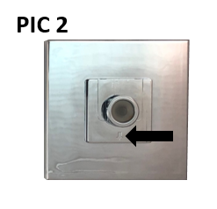
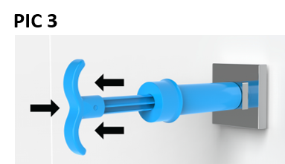
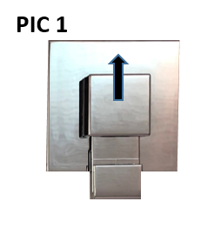
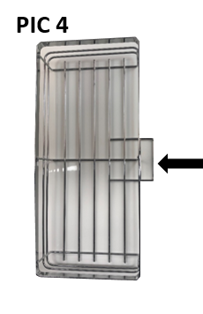

Visit www.fusionloc.com.au to view our installation and removal videos

HOW TO REMOVE YOUR FUSION-LOC ACCESSORY
- Remove your accessory from the mounting bracket (if applicable) and slide centre cap up and remove cap and bracket (note that some accessories do not require a mounting bracket).
- Using your finger, gently move centre valve sideways to release the vacuum, you should hear a little pssst sound. You are not required to remove the centre valve.
- Hold the suction cup and twist off the wall. HANDY HINT: You may be required to slide a thin object in between the suction cup and the wall to assist breaking the seal as the grey rubber can be a little tacky.

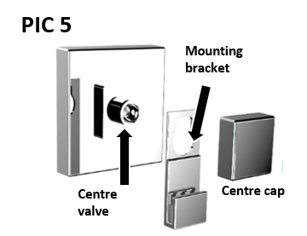
CLEANING INSTRUCTIONS
To clean the accessory and front of suction cup, use a damp cloth to wipe down all surface areas, leave to air dry and use a dry microfiber cloth to polish if required. Do not use any harsh cleaning solutions, bleaches or abrasive cleaners as they may damage the chrome coating. When cleaning the grey suction rubber ring use only warm running water and allow to air dry and avoid using a cloth as lint may from the cloth may interfere with adhesion.
TROUBLESHOOTING AND TECHNICAL ASSISTANCE
- Suction cup won’t stay on wall.
Possible causes
  - Your surface may be porous (suction products do not function on porous surfaces)
    - To determine if your wall is porous, install your suction cup onto a wall mounted mirror or glass shower screen. If you can install it successfully then your wall is porous and will not support any suction products unless used with an adhesive disc (sold separately). Please find a suitable area of glass, other non-porous surface or use an adhesive disc to install your accessory.
  - Centre Valve not functioning properly (PIC 6)
    - Remove the clear centre valve by prying out with finger nail or small blunt object. Ensure that it is free from debris. Push the valve back into the centre hole and re-install.
  - Grey sealing rubber contaminated (PIC 7)
    - Ensure that the grey rubber on the back of the suction cup is both free from dirt and grime and is also correctly imbedded into its groove. If it is dirty please rinse under warm water and allow to air dry.
- Centre cap won’t slide down over the valve.
  - Ensure that the suction cup has been placed on wall with the arrow facing down (PIC 1). If it hasn’t, please re-install with the arrow facing downwards.
For more information visit www.fusionloc.com.au and view our troubleshooting guides and videos.

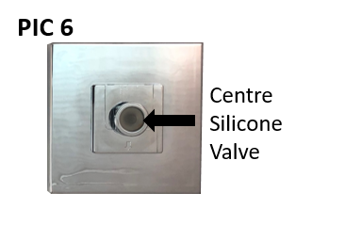
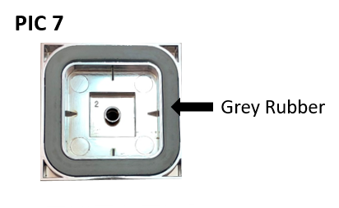

Precautions
The weight rating as indicated on the packaging is a maximum rating under ideal conditions and should be used as a guide only as the maximum weight may vary from surface top surface.

