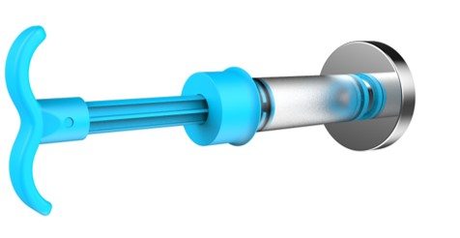
FUSION-LOC INSTALLATION INSTRUCTIONS
- Select where you want to mount your product. Ensure suction cups are not mounted on grout lines, joins, cracks or holes. Clean the mounting area with methylated spirits or cleaning alcohol and allow to air dry.
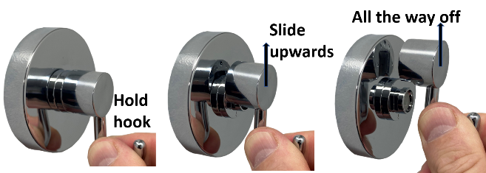
- If you have purchased a hook please follow this step otherwise go to STEP 3. While holding the suction cup in your hand, firmly hold the hook and slide it upwards to remove it from the base of the suction cup. This will reveal the centre valve. It may be a little stiff when it is brand new.

- Hold the suction cup firmly against the wall in the mounting position ensuring that the arrow below the centre valve is pointing downwards.
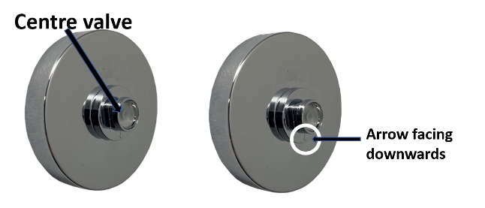

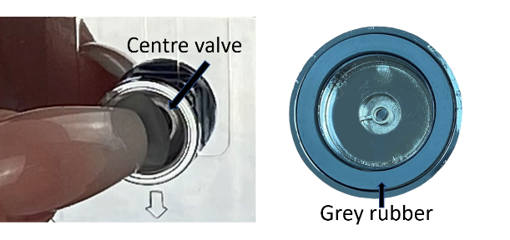
- While holding the suction cup with one hand use your other hand to place the pump over the centre valve. Apply a little force to the pump against the suction cup and pump 6-8 times. Ensure the pump maintains a tight seal around the centre valve. You should feel some resistance against the pump handle when pumping. Please note that you can pump as many times as you like as you cannot damage the suction cup by over pumping.
- If your accessory comes with two suction cups install the second suction cup now in the desired location.
- Test that you have attached your suction cups correctly by attempting to remove your suction cup with your hand. If you can pull it off then please re-install. If this persists please see our troubleshooting guide. If you are unable to remove the suction with your hand then you have installed it correctly.
- Attach your accessory by sliding the round centre caps down onto the suction cup. If they do not slide down please check that the arrow is facing down on the suction cup, refer to STEP 3.
FOR INSTALLATION VIDEOS PLEASE VISIT OUR WEBSITE
WWW.FUSIONLOC.COM.AU

HOW TO REMOVE YOUR EVOVAC ACCESSORY
- Slide centre caps up to remove your accessory from the suction cups.
- Using your fingernail, gently move the centre valve away from the side wall of the centre valve housing. This will allow air to travel inside the suction cup and will release the suction. You will hear a “psssst” sound which is the suction releasing. Please note that you do NOT remove the centre valve, if it does come out of the housing please push it back in.
- Using a slight twisting action, pull the suction cup off the wall. It may appear to be stuck as the grey sealing rubber can be sticky, this is normal. The grey rubber may remain on the wall. If this happens simply peel the grey rubber off the wall and insert back onto the back of the suction cup.
- Before re-installing your suction cup rinse sealing washer under warm water and allow to air dry.
FOR SUCTION CUP REMOVAL VIDEOS PLEASE VISIT OUR WEBSITE
WWW.FUSIONLOC.COM.AU

CARE AND MAINTENANCE
Wipe accessory dry after use with clean microfibre cloth. Do not use any cleaning chemicals on any part of the product as this may cause damage.
Clean accessory with a clean damp cloth and then wipe dry with a microfibre cloth. For peace of mind remove your accessory and repump 6 times while leaving your suction cup on your wall. When reinstalling rinse suction cups, rinse under warm water and let air dry before installing.
TROUBLESHOOTING GUIDE
- Suction cup falls off – Your surface is porous or centre valve is leaking air into suction cup. Firstly, test your suction cup by installing onto some glass like your shower screen. If it fails on glass contact us directly for a replacement suction cup.

evolve.enquiries@evolvelifewares.com.au

If it works on glass then your wall is porous, has a hair line crack or some other underlying reason that is allowing air to travel through the wall and into the suction cup. You will need to use our Porous Wall Adhesive Discs (product code 44561, sold separately).

- Centre cap won’t slide down – Ensure suction cup was installed with the arrow facing down (step 3).

Caution – The weight limit is to be used as a guide only and may vary from surface to surface. Do not overload. Do not place any items of value in accessory in case of unforeseen circumstances of suction cup failure.

WARRANTY PROCEDURE

For warranty claim or enquiry contact –

Email

evolve.enquiries@evolvelifewares.com.au

Phone

(02) 9415 2935

Mail

Evolve Lifewares
Suite 4, Level 3
2 Help St
Chatswood NSW 2067

Fusion-Loc is a registered trademark of Evolve Lifewares Pty Ltd

